***Manipulating Data(DML)***

**Practice 8 Solutions**

Insert data into the MY_EMPLOYEE table.

1. Run the statement in the lab8_1.sql script to build the MY_EMPLOYEE table that will be used for the lab.
2. **Ans:**

**CREATE TABLE my_employee**

**(id NUMBER(4) CONSTRAINT my_employee_id_nn NOT NULL,**

**last_name VARCHAR2(25),**

**first_name VARCHAR2(25),**

**userid VARCHAR2(8),**

**salary NUMBER(9,2));**

1. Describe the structure of the MY_EMPLOYEE table to identify the column names.

**Ans:**

**DESCRIBE my_employee;**

3. Add the first row of data to the MY_EMPLOYEE table from the following sample data. Do not list the columns in the INSERT clause.

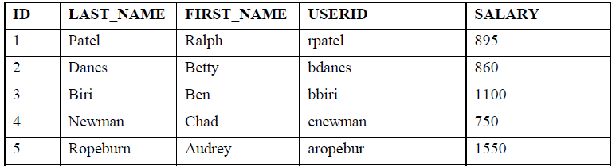

**INSERT INTO my_employee**

**VALUES (1, 'Patel', 'Ralph', 'rpatel', 895);**

1. Populate the MY_EMPLOYEE table with the second row of sample data from the preceding list. This time, list the columns explicitly in the INSERT clause.

**INSERT INTO my_employee (id, last_name, first_name,**

**userid, salary)**

**VALUES (2, 'Dancs', 'Betty', 'bdancs', 860);**

5. Confirm your addition to the table.

**Ans:**

**SELECT * FROM my_employee;**

6. Write an insert statement in a text file named loademp.sql to load rows into the

MY_EMPLOYEE table. Concatenate the first letter of the first name and the first seven characters of

the last name to produce the userid.

**SET ECHO OFF**

**SET VERIFY OFF**

**INSERT INTO my_employee**

**VALUES (&p_id, '&p_last_name', '&p_first_name',**

**lower(substr('&p_first_name', 1, 1) ||**

**substr('&p_last_name', 1, 7)), &p_salary);**

**SET VERIFY ON**

**SET ECHO ON**

7. Populate the table with the next two rows of sample data by running the insert statement in the

script that you created.

**SET ECHO OFF**

**SET VERIFY OFF**

**INSERT INTO my_employee**

**VALUES (&p_id, '&p_last_name', '&p_first_name',**

**lower(substr('&p_first_name', 1, 1) ||**

**substr('&p_last_name', 1, 7)), &p_salary);**

**SET VERIFY ON**

**SET ECHO ON**

8. Confirm your additions to the table.

**SELECT * FROM my_employee;**

9. Make the data additions permanent.

**COMMIT;**

Update and delete data in the MY_EMPLOYEE table.

10. Change the last name of employee 3 to Drexler.

**UPDATE my**_**employee**

**SET last**_**name = 'Drexler'**

**WHERE id = 3;**

11. Change the salary to 1000 for all employees with a salary less than 900.

**UPDATE my_employee**

**SET salary = 1000**

**WHERE salary < 900;**

12. Verify your changes to the table.

**SELECT last**_**name, salary**

**FROM my**_**employee;**

13. Delete Betty Dancs from the MY_EMPLOYEE table.

**DELETE**

**FROM my**_**employee**

**WHERE last**_**name = 'Dancs';**

14. Confirm your changes to the table.

**SELECT \***

**FROM my_employee;**

15. Commit all pending changes.

**COMMIT;**

Control data transaction to the MY_EMPLOYEE table.

16. Populate the table with the last row of sample data by modifying the statements in the script that you

created in step 6. Run the statements in the script.

**SET ECHO OFF**

**SET VERIFY OFF**

**INSERT INTO my_employee**

**VALUES (&p_id, '&p_last_name', '&p_first_name',**

**lower(substr('&p_first_name', 1, 1) ||**

**substr('&p_last_name', 1, 7)), &p_salary);**

**SET VERIFY ON**

**SET ECHO ON**

17. Confirm your addition to the table.

**SELECT * FROM my_employee;**

18. Mark an intermediate point in the processing of the transaction.

**SAVEPOINT step_18;**

19. Empty the entire table.

**DELETE FROM my_employee;**

20. Confirm that the table is empty.

**SELECT * FROM my_employee;**

21. Discard the most recent DELETE operation without discarding the earlier INSERT operation.

**ROLLBACK TO step_18;**

22. Confirm that the new row is still intact.

**SELECT * FROM my**_**employee;**

23. Make the data addition permanent.

**COMMIT;**